Why Be a Sponsor?
We are looking to participate with local businesses with one of New York’s premier winter events. Reeling for Recovery is an ice fishing contest which was founded five years ago. It has seen exponential growth throughout the North Country and needs your help to make it bigger. Without local businesses like you we could not run this event.
Funds generated by the Reeling For Recovery derbies have supplied over $40,000 to local programs to help at-risk kids during summer school since the event started.
The kid’s fishing derby is a wonderful family event that attracts dozens of kids every year. Fifty to 100 kids under the age of 12 are given a free ice rod and memories that will last a lifetime.
Derby rules are approved by the New York Department Environmental Conservation. The fish targeted are either invasive species or are released back if the angler decided to do so. This puts less strain on the lake and teaches you the importance of healthy harvesting.
The economic impact for the state is a welcome boost to area businesses. Lodging, restaurants, convenience stores, and businesses of all kinds benefit from the influx of tourists during a typically slow time of year.
More reasons to sponsor! •PROMOTES TOURISM Hundreds of visitors come into the region specifically for this event. It is an event that is looked forward to by young and old alike.
• ENVIRONMENTALLY CONSCIOUS EVENT Hundreds of Trout, Pike, and Perch are caught. Many are examined by the judges and released back into the local lakes.
• “SERVICE ABOVE SELF” Share our motto! We are a service organization, and school programs have benefited immensely from our donations.
• MAXIMIZE YOUR CHARITABLE CONTRIBUTIONS The Derbies are run by the Reeling for Recovery Charitable Fund which is a 501(c)3 organization. Your donation is fully tax deductible. There are no fees taken. Your money is working hard for those charities so desperately in need of your generous donation.

Pike-O-Nator

$700

Perch-Fectopm

$100

Bass-tastic

$300
$700 Pike-o-nator package includes:
-- Advertising through the New England area (C-stores, Bait stores, and Sport Good Stores)
-- Premium placement on all registration forms, signage, and banner ads
-- Name on weigh in stations and stage finals
-- Logo displayed on all online advertising. (We will also promote any events you may host)
-- Name listed on all event apparel that is created
-- 8 1/2 X 11 Ad sheet attached in every registration package (Optional)
-- Onsite-Vendor Booth Setup (Optional)
-- Recognition at award ceremony
-- Four registrations for the event and lunker pool
__________________________________________________________________________
$300 Bass-tastic package includes:
-- Advertising through the New England area (C-stores, Bait stores, and Sport Good Stores)
-- Logo displayed in all online advertising
-- Name listed on all event apparel that is created
-- 8 1/2 X 11 Ad sheet attached in every registration package (Optional)
-- Onsite-Vendor Booth Setup (Optional)
-- Recognition at award ceremony
-- Two registrations for the event and lunker poo
__________________________________________________________________________
$100 Perch-fection package includes:
-- Name listed on social media page
-- Onsite-Vendor Booth Setup (Optional)
-- Recognition at award ceremony
-- One registration for the event and lunker pool
SPONSORSHIP OPPORTUNITY
WHAT’S YOUR HOOK?

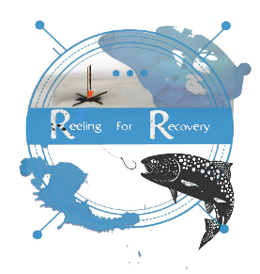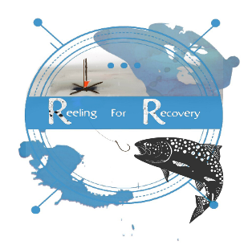
Please contact Jerry Haley for all advertisement opportunities
reeling4recovery@gmail.com
518-335-5375
All Donations can be paid in convenient installments if desired!

